|  |
| --- |
| EPAM Systems, RD Dep. |
| ETL and SQL Review |

|  |  |  |  |  |  |
| --- | --- | --- | --- | --- | --- |
| REVISION HISTORY | | | | | |
| Ver. | Description of Change | Author | Date | Approved | |
| Name | Effective Date |
|  |  | Vitaliya Adamchuk | 23-NOV-2017 |  |  |

Contents

1. CREATE Storage Objects 3

2. Generate Test Data in Storage Layers 3

2.1. Analyse 3

2.2. Create users and grants 3

2.3. External tables 4

2.4. Cleansing tables 5

2.5. Loading into cleansing tables 6

2.6. 3NF 7

2.7. 3NF Schema 9

3. SQL*Plus 9

3.1. Show execution plans in SQL*Plans 10

3.2. Set timing on 10

3.3. Run script 11

3.4. Save data to file 11

# CREATE Storage Objects

# Generate Test Data in Storage Layers

## Analyse

File iso_3166.tab has an information: country_id, country name, country code.

File iso_3166_geo_un_contries.tab has an information: country_id, country_name, region_id, region_name.

File iso_3166_geo_un.tab has an information: earth, continent, regions

Finally, our schema will looks like World<-Continents<-Regions<-Countries

## Create users and grants

CREATE USER sa_src

IDENTIFIED BY "123"

DEFAULT TABLESPACE tbs_pdb_test;

GRANT CONNECT TO sa_src;

GRANT RESOURCE TO sa_src;

--GRANT all privileges to sa_src;

CREATE USER bl_cl

IDENTIFIED BY "123"

DEFAULT TABLESPACE tbs_pdb_test;

GRANT CONNECT TO bl_cl;

GRANT RESOURCE TO bl_cl;

--GRANT all privileges to bl_cl;

CREATE USER bl_3nf

IDENTIFIED BY "123s"

DEFAULT TABLESPACE tbs_pdb_test;

GRANT CONNECT TO bl_3nf;

GRANT RESOURCE TO bl_3nf;

-- GRANT all privileges to bl_3nf;

CREATE DIRECTORY ext_tables

as '/media/sf_my';

Package for grants:

CREATE OR REPLACE PACKAGE grants_mgmt

AUTHID CURRENT_USER

AS

PROCEDURE GRANT_BLAT (GRANT_NAME IN VARCHAR2,

SCHEMA_NAME IN VARCHAR2,

OBJECT_NAME IN VARCHAR2,

USER_NAME IN VARCHAR2);

PROCEDURE GRANT_BLAT (GRANT_NAME IN VARCHAR2,

USER_NAME IN VARCHAR2,

WAO IN BOOLEAN := FALSE);

END grants_mgmt;

/

CREATE OR REPLACE PACKAGE BODY grants_mgmt AS

PROCEDURE GRANT_BLAT (GRANT_NAME IN VARCHAR2,

SCHEMA_NAME IN VARCHAR2,

OBJECT_NAME IN VARCHAR2,

USER_NAME IN VARCHAR2 )

IS

BEGIN

EXECUTE IMMEDIATE ('GRANT ' || GRANT_NAME || ' ON ' || SCHEMA_NAME || '.' || OBJECT_NAME || ' TO ' || USER_NAME);

END GRANT_BLAT;

PROCEDURE GRANT_BLAT (GRANT_NAME VARCHAR2, USER_NAME VARCHAR2, WAO IN BOOLEAN := FALSE) IS

BEGIN

IF WAO THEN

EXECUTE IMMEDIATE ('GRANT ' || GRANT_NAME || ' TO ' || USER_NAME || ' WITH ADMIN OPTION');

END IF;

EXECUTE IMMEDIATE ('GRANT ' || GRANT_NAME || ' TO ' || USER_NAME);

END;

END grants_mgmt;

/

EXEC grants_mgmt.grant_blat('CREATE ANY TABLE', 'SA_SRC');

EXEC grants_mgmt.grant_blat('SELECT ANY TABLE', 'SA_SRC');

EXEC grants_mgmt.grant_blat('READ,WRITE ON DIRECTORY ext_tables', 'SA_SRC');

EXEC grants_mgmt.grant_blat('CREATE ANY TABLE', 'BL_CL');

EXEC grants_mgmt.grant_blat('SELECT ANY TABLE', 'BL_CL');

EXEC grants_mgmt.grant_blat('READ,WRITE ON DIRECTORY ext_tables', 'BL_CL');

EXEC grants_mgmt.grant_blat('CREATE ANY TABLE', 'BL_3NF');

EXEC grants_mgmt.grant_blat('SELECT ANY TABLE', 'BL_3NF');

## External tables

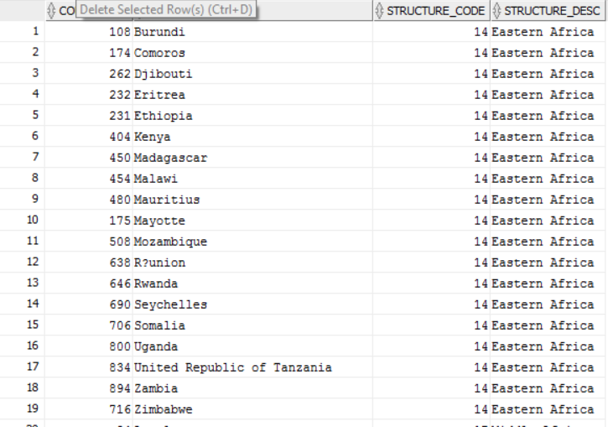

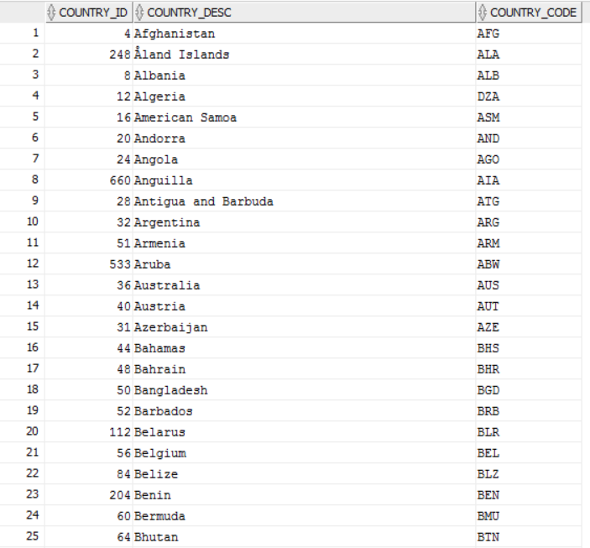

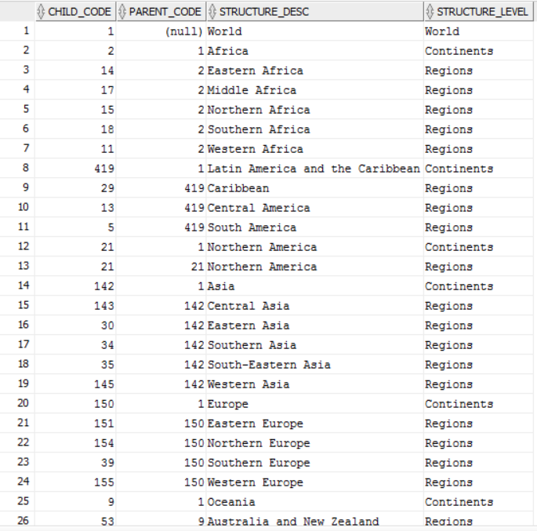

## Cleansing tables

CREATE TABLE cl_world

(

world_id NUMBER(10),

world_desc VARCHAR2 ( 200)

);

CREATE TABLE cl_continents

(

continent_id NUMBER(10),

continent_desc VARCHAR2 ( 200 ),

global_id NUMBER(10)

);

CREATE TABLE cl_regions

(

region_id NUMBER(10),

region_desc VARCHAR2 ( 200 ),

continent_id NUMBER(10)

);

CREATE TABLE cl_countries(

country_id NUMBER(10),

country_desc VARCHAR2 ( 200 ),

country_code VARCHAR2 ( 200 ),

region_id NUMBER(10)

);

## Loading into cleansing tables

CREATE OR REPLACE PACKAGE pkg_etl_geo

AS

PROCEDURE load_worlds;

PROCEDURE load_continents;

PROCEDURE load_regions;

PROCEDURE load_countries;

END pkg_etl_geo;

/

CREATE OR REPLACE PACKAGE body pkg_etl_geo as

PROCEDURE load_worlds

IS

BEGIN

EXECUTE immediate 'truncate table cl_world';

INSERT INTO cl_world

(world_id,

world_desc)

SELECT child_code,

structure_desc

FROM sa_src.ext_geo_structure_iso3166

WHERE structure_level='World';

COMMIT;

EXCEPTION

WHEN OTHERS THEN

RAISE;

END load_worlds;

PROCEDURE load_continents

IS

BEGIN

EXECUTE immediate 'truncate table cl_continents';

INSERT INTO cl_continents

(continent_id,

continent_desc,

global_id)

SELECT child_code,

structure_desc,

parent_code

FROM sa_src.ext_geo_structure_iso3166

WHERE structure_level='Continents';

COMMIT;

EXCEPTION

WHEN OTHERS THEN

RAISE;

END load_continents;

PROCEDURE load_regions

IS

BEGIN

EXECUTE immediate 'truncate table cl_regions';

INSERT INTO cl_regions

(region_id,

region_desc,

continent_id)

SELECT child_code,

structure_desc,

parent_code

FROM sa_src.ext_geo_structure_iso3166

WHERE structure_level='Regions';

COMMIT;

EXCEPTION

WHEN OTHERS THEN

RAISE;

END load_regions;

PROCEDURE load_countries

IS

BEGIN

EXECUTE immediate 'truncate table cl_countries';

INSERT INTO cl_countries

(country_id,

country_desc,

country_code,

region_id)

SELECT country.country_id,

country.country_desc,

country.country_code,

region.STRUCTURE_CODE

FROM SA_SRC.EXT_GEO_COUNTRIES_ISO3166 country

JOIN SA_SRC.EXT_CNTR2STRUCTURE_ISO3166 region

ON country.COUNTRY_ID=region.COUNTRY_ID;

COMMIT;

EXCEPTION

WHEN OTHERS THEN

RAISE;

END load_countries;

END pkg_etl_geo;

/

EXEC PKG_ETL_GEO.load_worlds;

EXEC PKG_ETL_GEO.load_continents;

EXEC PKG_ETL_GEO.load_regions;

EXEC PKG_ETL_GEO.load_countries/

## 3NF

REATE TABLE ce_worlds

(

world_id NUMBER(10,0) PRIMARY KEY ,

world_desc VARCHAR2 ( 200 CHAR ) NOT NULL

);

CREATE TABLE ce_regions

(

region_id NUMBER(10,0) PRIMARY KEY,

region_desc VARCHAR2 ( 200 CHAR ) NOT NULL,

continent_id NUMBER(10,0) NOT NULL

);

CREATE TABLE ce_countries

(

country_id NUMBER(10,0) PRIMARY KEY NOT NULL,

country_desc VARCHAR2 ( 200 CHAR ) NOT NULL,

country_code VARCHAR2 ( 3 ),

region_id NUMBER(10,0)NOT NULL);

CREATE TABLE ce_continents

(

continent_id NUMBER(10,0) PRIMARY KEY ,

continent_desc VARCHAR2 ( 200 CHAR ) NOT NULL,

world_id NUMBER(10,0) NOT NULL);

INSERT INTO ce_worlds

(world_id,

world_desc)

SELECT world_id,

world_desc

FROM bl_cl.cl_world;

INSERT INTO ce_continents

(continent_id,

continent_desc,

world_id)

SELECT continent_id,

continent_desc,

world_id

FROM bl_cl.cl_continents;

INSERT INTO ce_regions

(region_id,

region_desc,

continent_id)

SELECT region_id,

region_desc,

continent_id

FROM bl_cl.cl_regions;

INSERT INTO ce_countries

(country_id,

country_desc,

country_code,

region_id)

SELECT country_id,

country_desc,

country_code,

region_id

FROM bl_cl.cl_countries;

Alter table ce_regions ADD CONSTRAINT FK_continent_id FOREIGN KEY (continent_id)

REFERENCES ce_continents(continent_id);

Alter table ce_countries add CONSTRAINT FK_country_id FOREIGN KEY (region_id)

REFERENCES ce_regions(region_id);

Alter table ce_continents add CONSTRAINT FK_world_id FOREIGN KEY (world_id)

REFERENCES ce_worlds (world_id) ;

INSERT INTO ce_worlds

(world_id,

world_desc)

SELECT world_id,

world_desc

FROM bl_cl.cl_world;

INSERT INTO ce_continents

(continent_id,

continent_desc,

world_id)

SELECT continent_id,

continent_desc,

global_id

FROM bl_cl.cl_continents;

INSERT INTO ce_regions

(region_id,

region_desc,

continent_id)

SELECT region_id,

region_desc,

continent_id

FROM bl_cl.cl_regions;

INSERT INTO ce_countries

(country_id,

country_desc,

country_code,

region_id)

SELECT country_id,

country_desc,

country_code,

region_id

FROM bl_cl.cl_countries;

## 3NF Schema

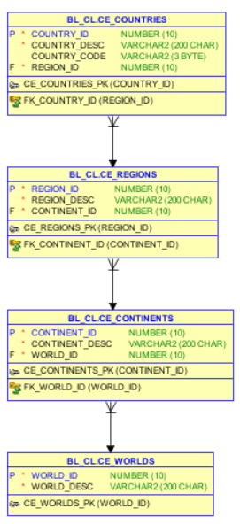

# SQL*Plus

Connect to a database via SQL*Plus client and do next steps:

## Show execution plans in SQL*Plans

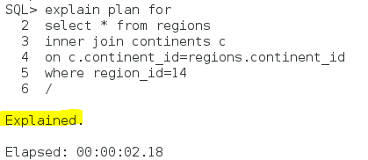

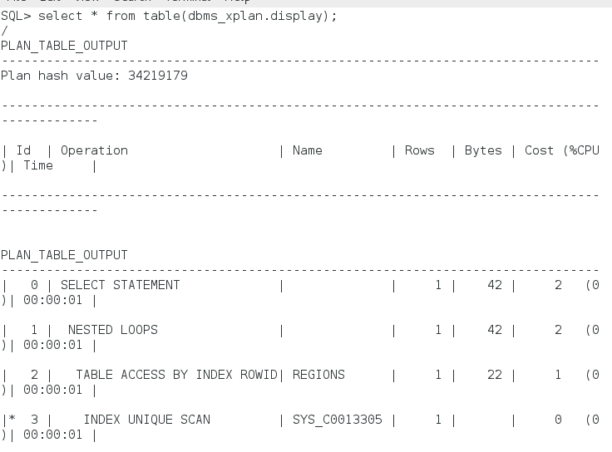

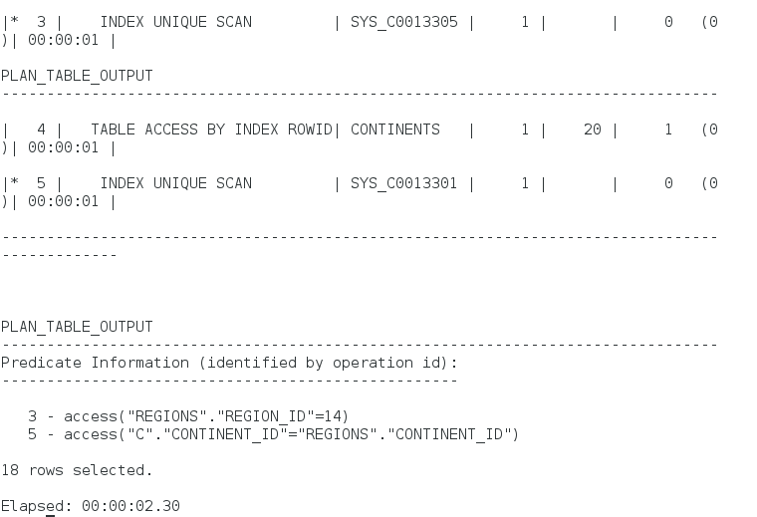

## Set timing on



## Run script

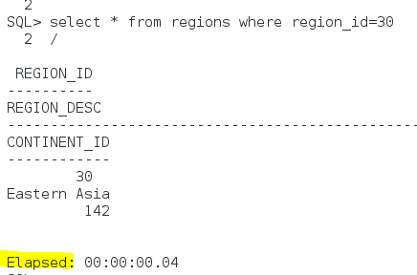

## Save data to file

